21.46: Calculate in vector form the electric field for each charge, and add them.
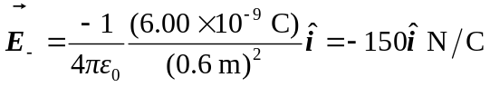
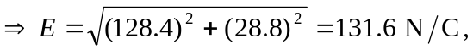 at 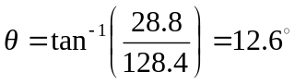 up from axis.

